OBSERVATION1:

It is Register in wireframe but sign up text in sign up page.

Sign up page: 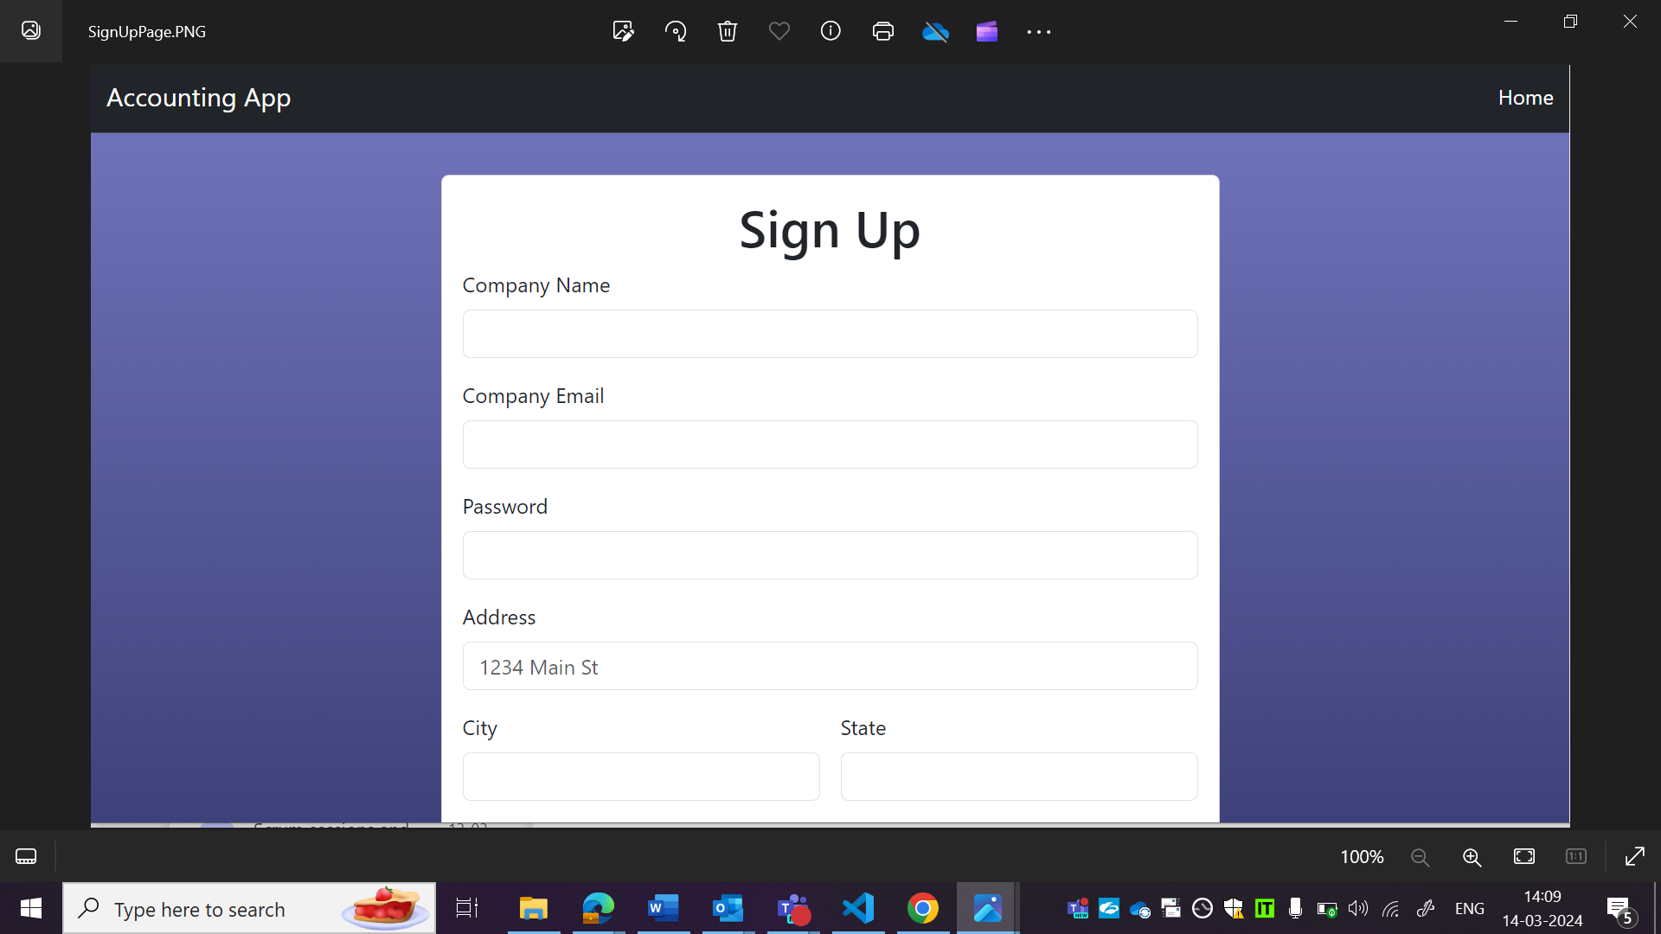

Wireframe:

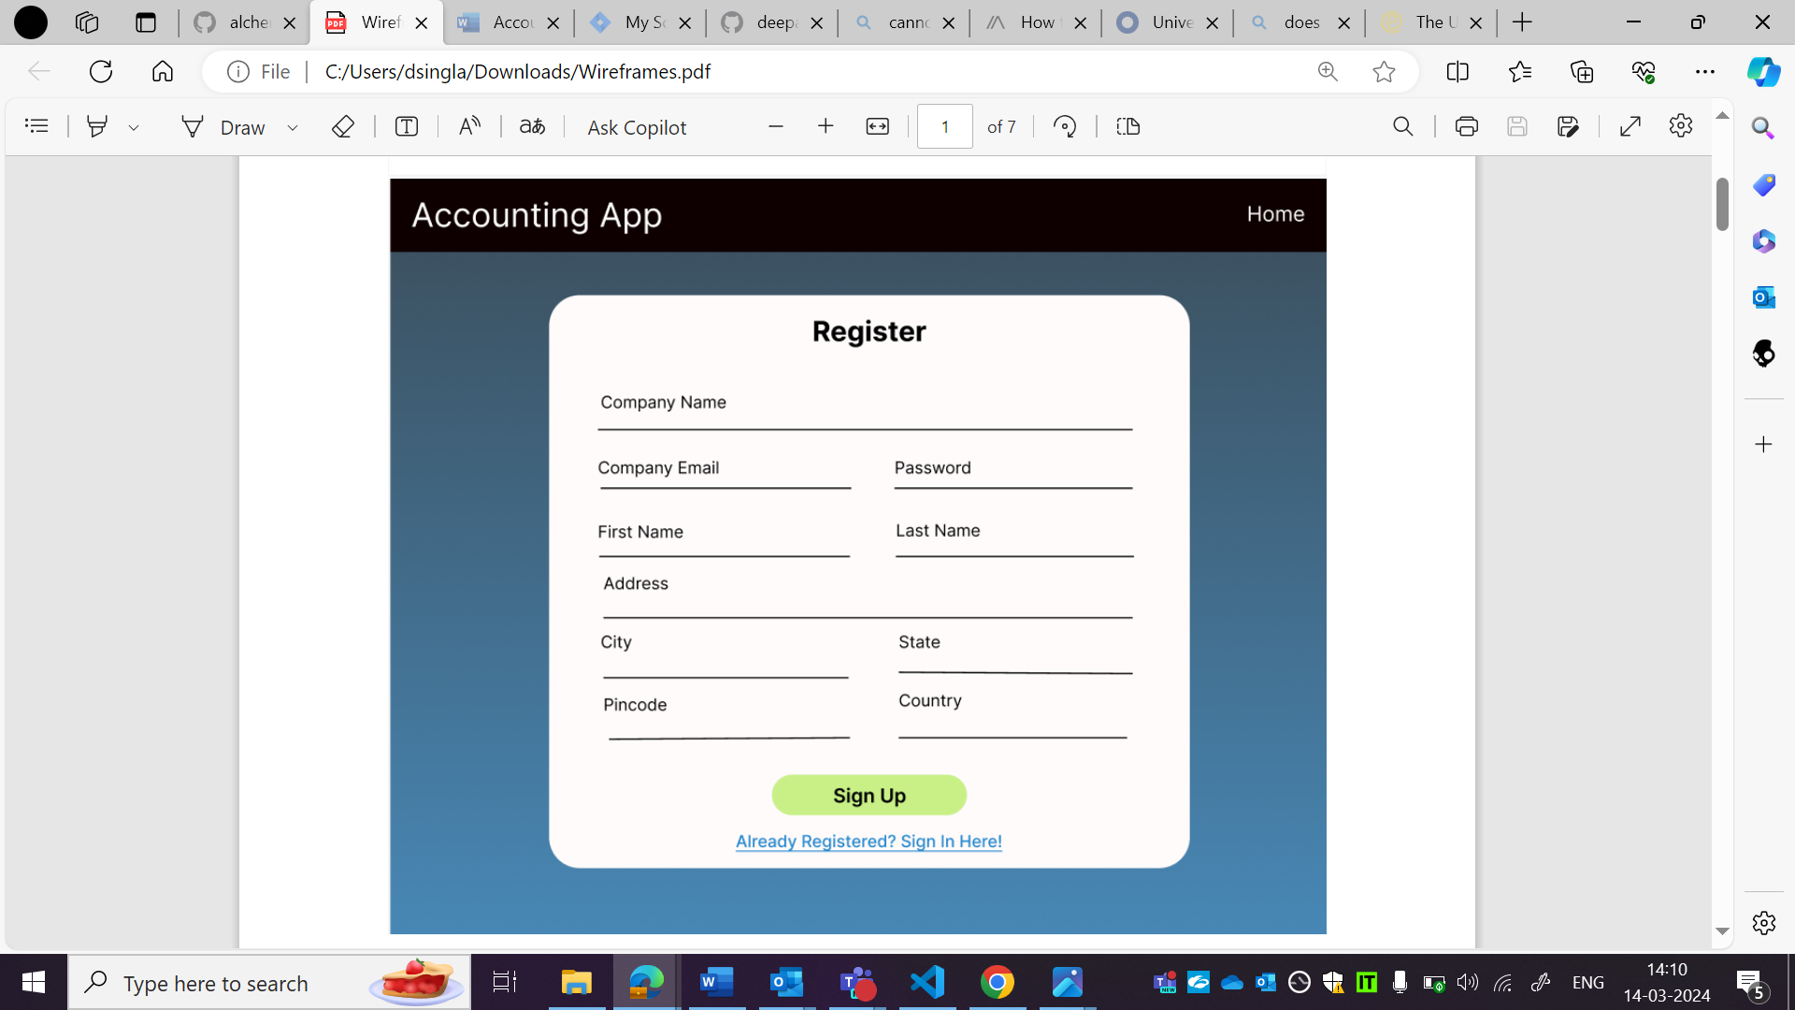

OBSERVATION2:

It is Register in wireframe but sign up text in sign up page.

Sign up page: 

Wireframe:



OBSERVATIO3:

Password field is not in correct place as per wireframe.

First name and surname field are there in wireframe but in sign up page.

Sign up page: 

Wireframe:



OBSERVATION4:

Country field is not in correct place as per wireframe.

Sign up page: 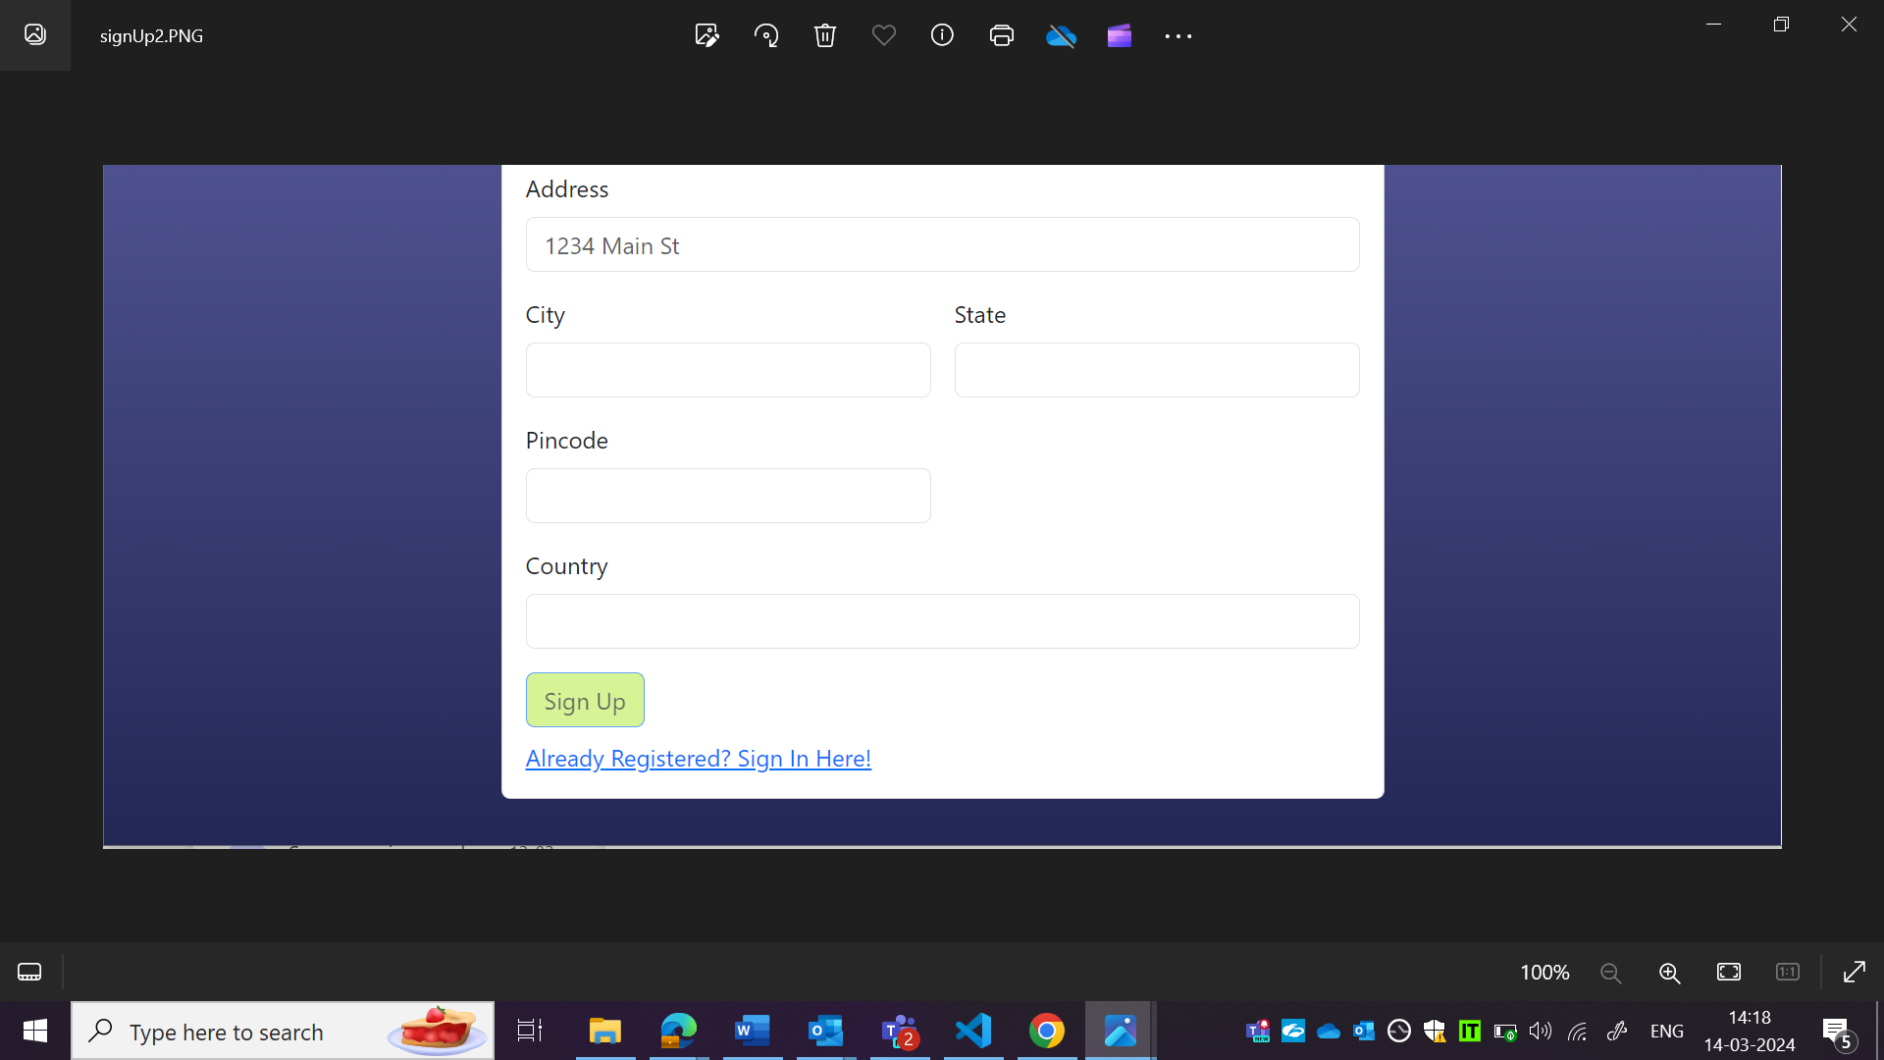

Wireframe:



OBSERVATION5:

Highlighted text is not centre aligned as per wireframe.

Sign up button is not in same style as wireframe.

Sign up page: 

Wireframe:

